Apply filters to SQL queries

Project description

I need to obtain specific information about employees, their machines, and the departments they belong to from the database. I need data to investigate potential security issues and to update computers. I am responsible for filtering the required information from the database.

Retrieve after hours failed login attempts

There was a potential security incident that occured after business hours and failed login attempts during this time need to be investiagted.

This SQL statement selects all of the columns from the log_in_attempts table where the value for the column login_time is greater than specified (18:00) and the value for the column success is false (0).

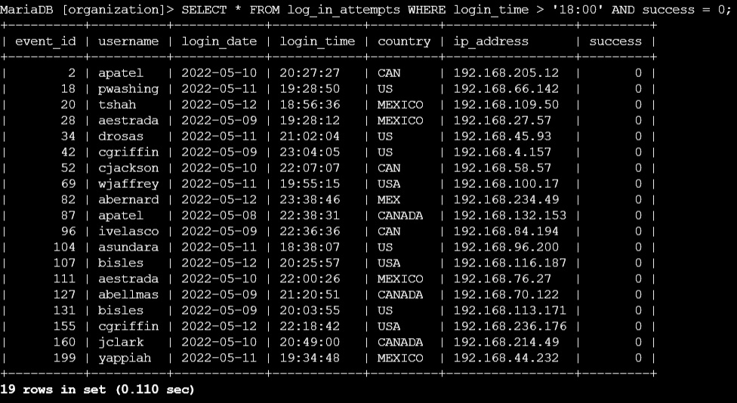

Retrieve login attempts on specific dates

I am investigating a suspicious event that occured 2022-05-09 and I need login information for this day and the day before.

This SQL statement selects all of the columns from the table log_in_attempts where the value for the column login_date is one of the specified dates (2022-05-09 or 2022-05-08).

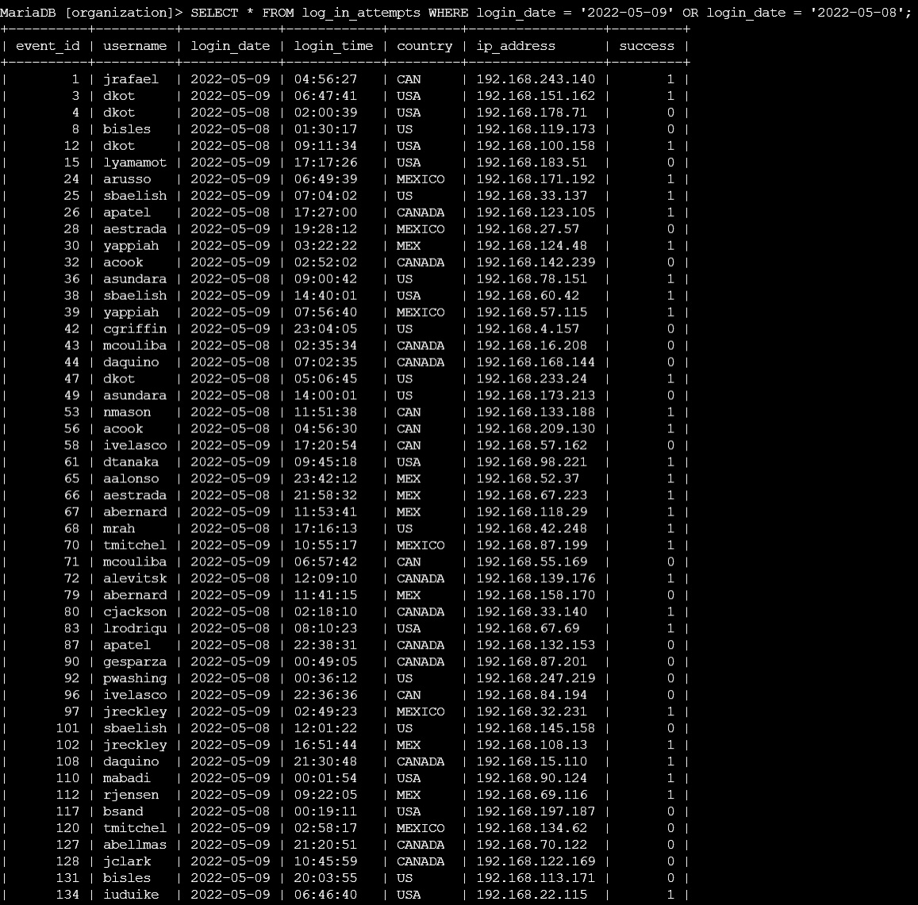

Retrieve login attempts outside of Mexico

I have a suspicion that there is a problem with login attempts that occured outside of Mexico.

This SQL statement selects all of the columns from the table log_in_attempts where the value for the column country does not start with MEX.

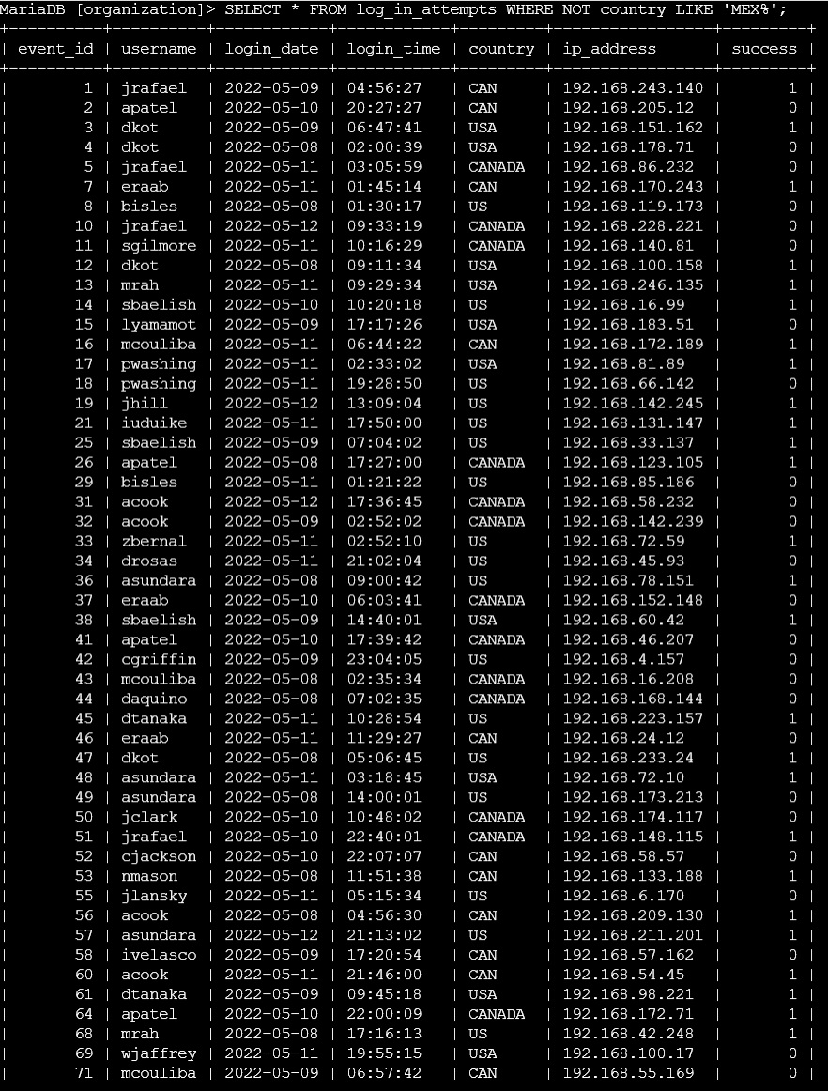

Retrieve employees in Marketing

I need information about employees from the marketing department so I can update their computers.

This SQL statement selects all of the columns from the table employees where the value for the column department is Marketing and the value for the column office starts with East.

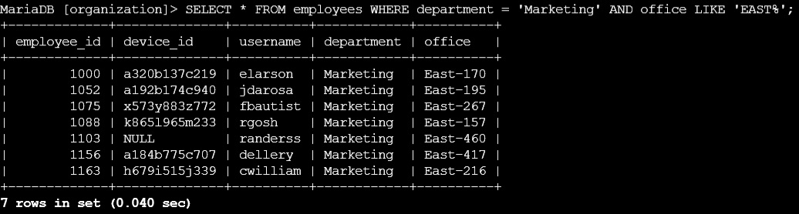

Retrieve employees in Finance or Sales

I need information on employees from the Finance and Sales departments so I can update their computers.

This SQL statement selects all of the columns from the table employees where the value for the column department is Finance or Sales.

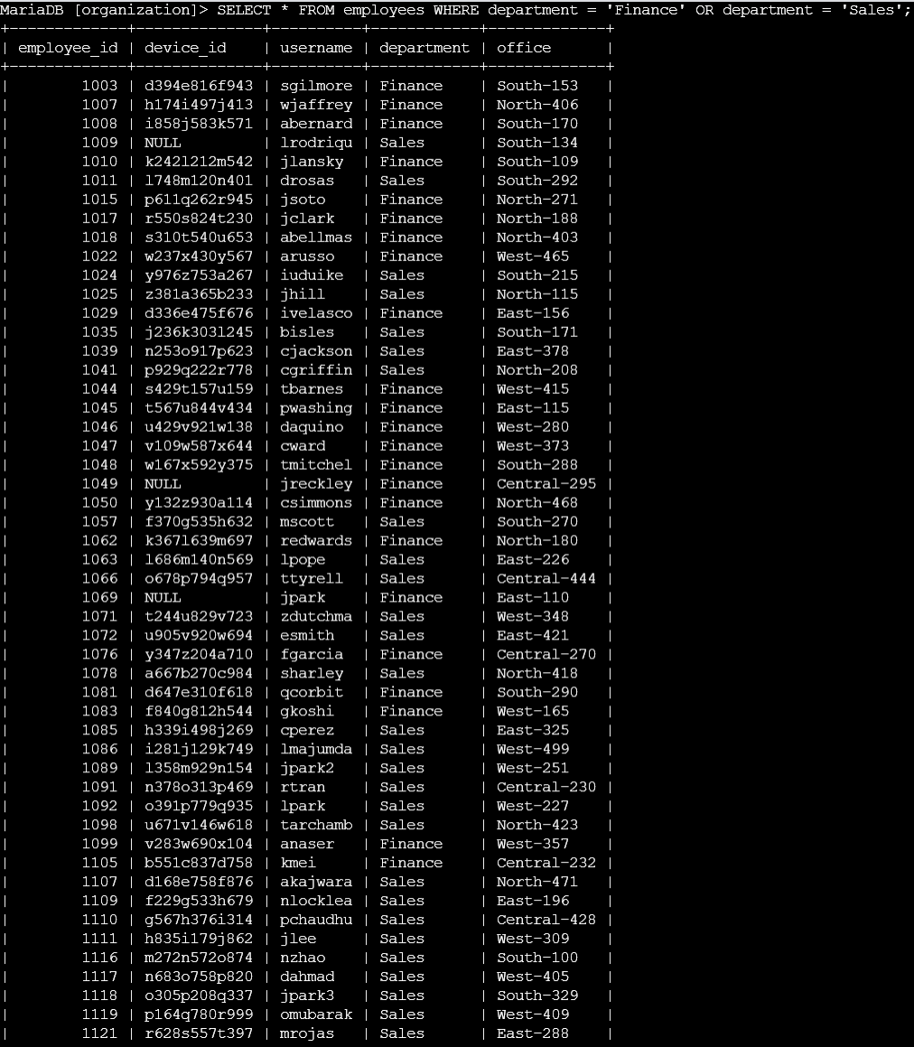

Retrieve all employees not in IT

I need information on all employees not in the information technology department so I can update their computers.

This SQL statement selects all of the columns from the table employees where the value for the column department is not Information Technology.

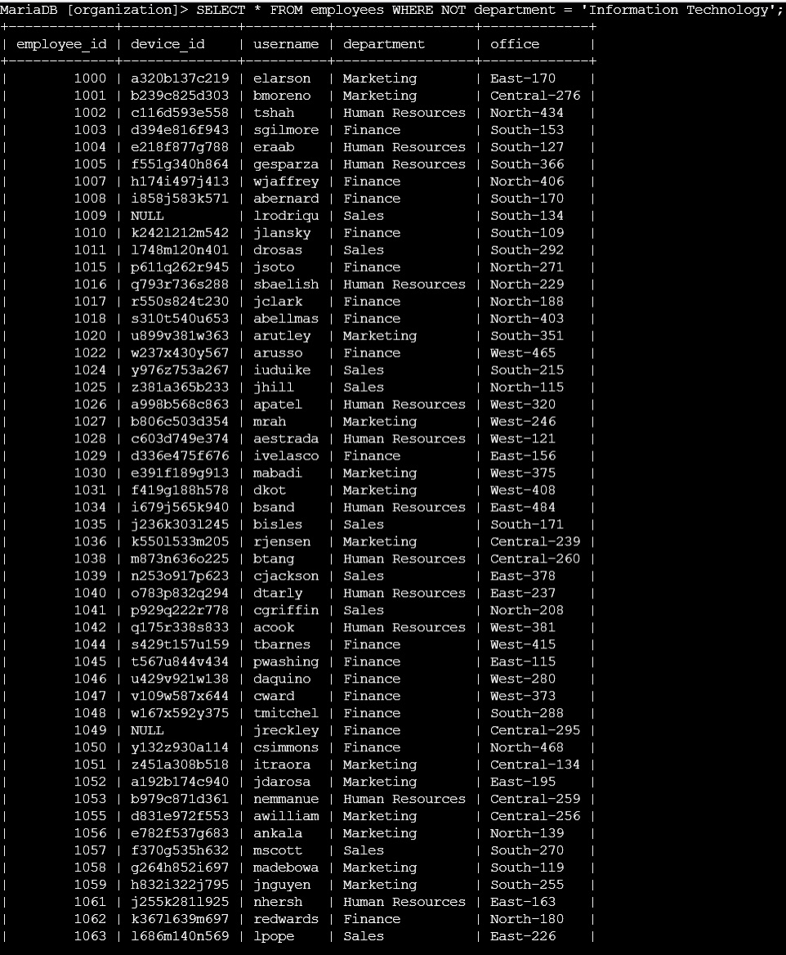

Summary

I was able to successfully select for all the data I needed using SQL filtering.

